|  |
| --- |
| Canberra Grammar School |
| AATCS User Guide |
| Lochie Ferrier (26505585) |

|  |
| --- |
| Lochie  5/30/2014 |

Contents

Introduction 2

Hardware Specifications 2

Installation Guide 2

User Manual 4

Data Files 4

Aircraft.txt 4

Commands.txt 5

Targets.txt 6

Interface and Commands 7

Interface Description 7

Using Commands 8

Troubleshooting Guide 9

# Introduction

AATCS is an experimental piece of software designed to demonstrate the possibility of an automated air traffic control system. It allows a user to test the performance of an air traffic control algorithm in various scenarios and view and record the outcomes of simulations. It is not intended as a game or even a program of any real application. It is a piece of software created for research purposes only.

# Hardware Specifications

AATCS is a fairly advanced program that performs an enormous amount of computation for every time step that it simulates. Though the amount of aircraft and targets simulated at any one time can be adjusted to help make the simulation run more smoothly, it is recommended to at least use a computer with these specifications.

* Operating System: Windows 7
* Prerequisite Software: Microsoft Visual Basic 2010 Express IDE
* Windows Experience Index: 4
* RAM: 4 GB
* Dedicated Graphics Memory: 64MB
* Required External Hardware: Keyboard, Mouse

# Installation Guide

AATCS is a program designed for experimentation. As such, it is not packaged compiled but rather as a Visual Basic Project. Here is a guide for installing and running the project on a machine with Visual Basic 2010 Express.

|  |  |
| --- | --- |
| Locate the AATCS zipped or compressed folder on your machine. | C:\Users\Lochie\Documents\Screenshots\screenshot.1.png |
| Right click on the folder and select Extract All to show this screen. Select “Show extracted files when complete” and click Extract. | C:\Users\Lochie\Documents\Screenshots\screenshot.2.png |
| A window should open now showing the decompressed contents of the AATCS zip. Double click on the AATCS Microsoft Visual Studio Solution File.  Note for experienced users: AATCS comes with a small amount of sample target and aircraft data in Aircraft.txt and Target.txt to ease the introduction to the software. You may wish to edit these files before starting Visual Basic 2010 Express. | C:\Users\Lochie\Documents\Screenshots\screenshot.3.png |
| Visual Basic 2010 Express should have now opened. If you are unfamiliar with the software, please be careful not to edit any source files as this may interfere with the correct operation of the program. Click the green play symbol to run the program. Please refer to the User Manual section for usage of the program itself. | C:\Users\Lochie\Documents\Screenshots\screenshot.4.png |

# User Manual

AATCS is intended to be used as a simulation program for testing various automated air traffic control algorithms. As such, once the initial conditions of the simulation have been set few modifications can be made.

## Data Files

Within the AATCS project folder at the path AATCS\AATCS\AATCS\AATCS\bin\Debug\Data is a collection of text files. The three files, Aircraft.txt, Commands.txt and Targets.txt are used to create initial conditions for a simulation as well as record the events of an execution of the program. Note that some sample data is provided in the Aircraft.txt and Targets.txt files to help beginners learn how to use the software.

### Aircraft.txt

This file stores all the aircraft that are currently in circulation. Each aircraft is stored as an aircraft record which has the following fields or values.

* x: The x coordinate of the aircraft in the simulation space stored as an integer. Must be positive and less than or equal to 90000.
* y: The y coordinate of the aircraft in the simulation space stored as an integer. Must be positive and less than or equal to 90000.
* altitude: The current altitude of the aircraft above the flat simulation “ground” as an integer.
* tgtAltitude: As the aircraft must climb and descend over multiple time steps, a value for the altitude for which the aircraft is aiming must be stored. This enables the simulation to then simulate how a pilot would direct an aircraft to climb or descend, levelling off when the required altitude is reached. This field stores that value as an integer.
* hdg: The current heading of the aircraft as a bearing with the top of the screen as North. Value between 0 and 359.
* tgtHdg: For the same reasons as why a tgtAltitude must be stored, a tgtHdg is stored as an integer. Note: do not confuse this with the approachHdg of the Target object. They are entirely different entities
* Target: This is the target for which the aircraft is aiming and it is stored as a target record. Full description of this record is in the Targets.txt section.
* callSign: The unique call sign of the aircraft stored as a string. Random assignment gives all aircraft call signs the prefix of “QF” followed by a three digit number however any call sign can be written to the file as long as it is not null.
* goAroundStatus: Whether the aircraft is currently performing a go around manoeuvre, stored as a Boolean value.

The file must be formatted correctly; otherwise the program will encounter an error. Here is an example with annotations for explanation:

Note that commas must be used to separate values or fields and a standard carriage return should be used to create a new line.



### Commands.txt

This file simply logs all the commands issued with timestamps for the purposes of tracking a simulation. Editing it has no effect on the program’s execution.

### Targets.txt

This file stores all the targets that are drawn and are used to create new aircraft. Each target is stored as a target record which has the following fields or values.

* x: The x coordinate of the target in the simulation space stored as an integer. Must be positive and less than or equal to 90000.
* y: The y coordinate of the target in the simulation space stored as an integer. Must be positive and less than or equal to 90000.
* approachHdg: The heading on which an aircraft must approach the target, stored as an integer.
* name: The name of the target, stored as a string.

name

y

x

This is the sentinel value. It must be included or an error will be encountered.

approachHdg

00563,09500,00350,PAP1L

9999

## Interface and Commands

### Interface Description

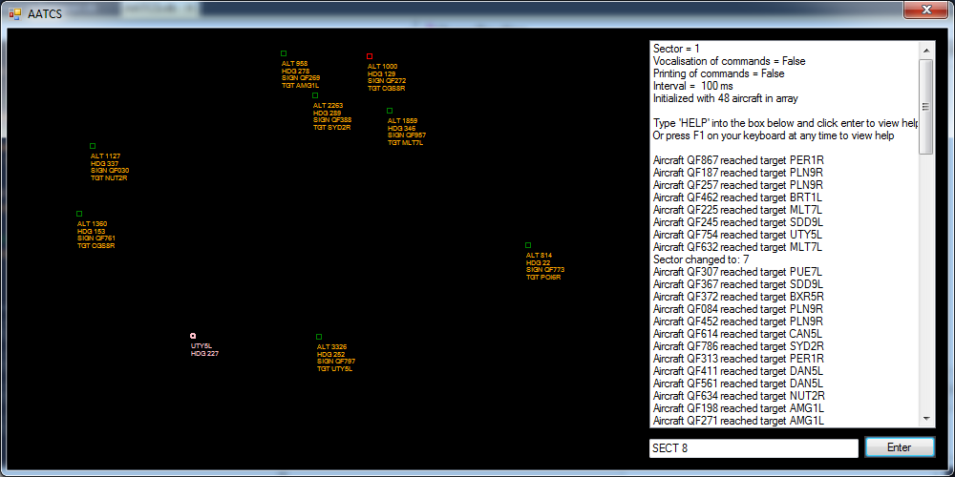

Aircraft

Target

List box

Input box

Enter button

AATCS displays symbols representing aircraft and targets in the simulation to allow the user to see what the simulation is doing.

|  |  |  |
| --- | --- | --- |
| **Symbol** | **Example** | **Explanation** |
| Target | C:\Users\Lochie\Documents\Screenshots\target.png | The small circle shows the exact location of the target on the xy plane. The lines of text show:   1. Name of the target (UTY5L) 2. Approach heading for the target (227) |
| Aircraft | C:\Users\Lochie\Documents\Screenshots\aircraft.png | The small square shows the exact location of the aircraft on the xy plane. The square also shows what the goAroundStatus of the aircraft is.   * C:\Users\Lochie\Documents\Screenshots\green.png - Square is green so goAroundStatus is false. * C:\Users\Lochie\Documents\Screenshots\red.png - Square is red so goAroundStatus is true.   The lines of text show:   * Altitude of the aircraft (814) * Heading of the aircraft (22) * Aircraft’s call sign (QF773) * Aircraft’s target (POI6R) |

### Using Commands

There are various values which one may wish to change whilst the program is operating. To do this, a commands system has been included in AATCS. To use the system, type a command in the input box and click Enter. A message should show in the list box telling you whether the command has been executed. The table below details use of all the available commands.

|  |  |  |  |
| --- | --- | --- | --- |
| **Format (X is input)** | **Description** | **Range of input** | **Examples** |
| SECT X | Changes the sector currently being displayed. Sectors are the regions of the xy plane that can be displayed on screen. This is the arrangement:  C:\Users\Lochie\Documents\Screenshots\screenshot.9.png | 1 - 9 | SECT 1  SECT 9  SECT 3 |
| VOXC X | Enables or disables the vocalisation of commands by a speech synthesis engine. If N is input then commands are not vocalised, if Y is input then commands are vocalised. *Warning: enabling vocalisation of commands with more than approximately 5 aircraft in circulation can cause large delays.* | Y or N | VOXC Y  VOXC N |
| NUMA XXX | Changes the number of aircraft in the simulation. Note that this will only increase the number of aircraft in the simulation. Aircraft are only deleted by the program when they reach their target or fly out of bounds. | 0 - 999 | NUMA 397  NUMA 001  NUMA 000  NUMA 999  NUMA 043 |
| PRNT X | Changes whether the program prints commands to the list box. If N is input then commands are not printed, if Y is input then commands are printed. | Y or N | VOXC N  VOXC Y |
| TIME XXXX | Changes the time interval (in ms) of the program. The program performs simulation cycles at the frequency of this interval. If leading zeroes are not included in the input for this command an “Invalid input” message will be returned. | 10 – 9999 | TIME 0010  TIME 3200  TIME 0342 |
| HELP | This is simply the command for opening this help file. | N/A | HELP |

# Troubleshooting Guide

Program crashes, Visual Basic opens and a section of code is highlighted.

|  |  |
| --- | --- |
| **Debugger Message** | **Cause/Solution** |
| InvalidCastException message is shown by Visual Basic | There is invalid data in a file, causing a failure when the program attempts to read in data. Check Aircraft.txt and Targets.txt for invalid data (such as -*&^#), delete or correct the data, save the file and restart the program. |
| “Invalid input” is printed to the list box after entering a command | A command has been incorrectly formatted, and cannot be understood or used by AATCS. Consult the “Using Commands” section of this help guide to find the correct information on how to use a particular command. |
| No aircraft appear and a grey background is shown. | There are no aircraft in the array. This can be caused by two things. Either the number of aircraft variable has been set to zero or there are no valid aircraft in the Aircraft.txt. To fix this problem simply set the number of aircraft to a value greater than 0 using the NUMA command. |
| Program will not run when green play button is clicked. | Files are not included or code has been incorrectly modified. To fix reinstall the program using the installation guide provided above, check hardware specifications and if all else fails source a new copy of AATCS and Visual Basic 2010 Express. |